EXPT NO:4A | EXPLORATORY DATA ANALYSIS (EDA) – DATA INSPECTION, FILTERING, STATISTICAL ANALYSIS AND CORRELATION

Aim:
To perform data inspection, filtering, grouping, aggregation, descriptive statistical analysis, and correlation analysis using Pandas and visualize the results using Matplotlib.

Algorithm:
- Import the required Pandas, NumPy and Matplotlib libraries.
- Read the stud_data.csv file using Pandas.
- Display the dataset and inspect the first few records.
- Find the number of rows and columns and display the data types.
- Generate the statistical summary of the dataset.
- Filter the students based on marks and attendance conditions.
- Sort the student records based on marks and attendance.
- Group the data based on department and calculate average marks and attendance.
- Calculate mean, median, minimum, maximum and standard deviation of marks.
- Calculate the correlation between marks and attendance.
- Create bar chart, line chart, scatter plot, histogram and box plot using Matplotlib.
- Display the results and interpret the obtained data.

Program:
# Import libraries import pandas as pd import numpy as np
import matplotlib.pyplot as plt

# Read dataset

df = pd.read_csv("stud_data.csv")

# Display dataset print(df)

# Display first five records print(df.head())

# Display shape print(df.shape)

# Display data types print(df.dtypes)

# Display statistical summary print(df.describe())

# Filter students with marks greater than 80

print(df[df["Marks"] > 80])

# Filter students with attendance greater than 90 print(df[df["Attendance"] > 90])

# Sort students by marks print(df.sort_values("Marks", ascending=False))

# Sort students by attendance print(df.sort_values("Attendance", ascending=False))

# Department-wise average marks print(df.groupby("Department")["Marks"].me an())

# Department-wise average attendance print(df.groupby("Department")["Attendance"].mean())

# Calculate mean

print("Mean Marks:", df["Marks"].mean())

# Calculate median

print("Median Marks:", df["Marks"].median())

# Calculate minimum

print("Minimum Marks:", df["Marks"].min())

# Calculate maximum

print("Maximum Marks:", df["Marks"].max())

# Calculate standard deviation

print("Standard Deviation:", df["Marks"].std())

# Display correlation matrix print(df[["Marks",
"Attendance"]].corr())

# Display correlation between marks and attendance print("Correlation:", df["Marks"].corr(df["Attendance"]))

# Bar chart plt.bar(df["Name"],
df["Marks"]) plt.title("Student Marks") plt.xlabel("Name") plt.ylabel("Marks") plt.show()

# Calculate maximum

print("Maximum Marks:", df["Marks"].max())

# Calculate standard deviation

print("Standard Deviation:", df["Marks"].std())

# Display correlation matrix print(df[["Marks",
"Attendance"]].corr())

# Display correlation between marks and attendance print("Correlation:", df["Marks"].corr(df["Attendance"]))

# Bar chart plt.bar(df["Name"],
df["Marks"]) plt.title("Student Marks") plt.xlabel("Name") plt.ylabel("Marks") plt.show()
# Calculate maximum

print("Maximum Marks:", df["Marks"].max())

# Calculate standard deviation

print("Standard Deviation:", df["Marks"].std())

# Display correlation matrix print(df[["Marks",
"Attendance"]].corr())

# Display correlation between marks and attendance print("Correlation:",

df["Marks"].corr(df["Attendance"]))

# Bar chart plt.bar(df["Name"],
df["Marks"]) plt.title("Student Marks") plt.xlabel("Name") plt.ylabel("Marks") plt.show()

# Line chart

plt.plot(df["Name"], df["Attendance"], marker="o") plt.title("Student Attendance") plt.xlabel("Name")
plt.ylabel("Attendance")

plt.show()

# Scatter plot plt.scatter(df["Attendance"], df["Marks"]) plt.title("Marks vs Attendance")

plt.xlabel("Attendance") plt.ylabel("Marks") plt.show()

# Histogram plt.hist(df["Marks"], bins=5) plt.title("Marks Distribution") plt.xlabel("Marks") plt.ylabel("Number of Students") plt.show()

# Box plot plt.boxplot(df["Marks"
]) plt.title("Marks Box Plot") plt.ylabel("Marks") plt.show()

Output:
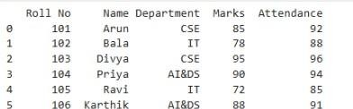

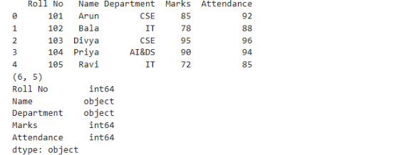

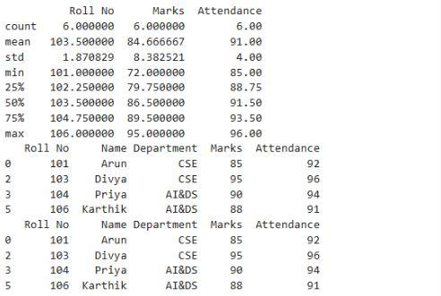

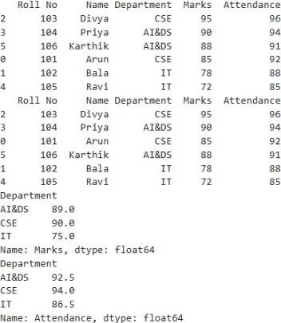

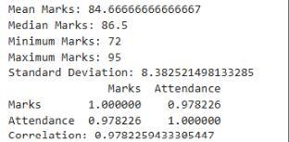
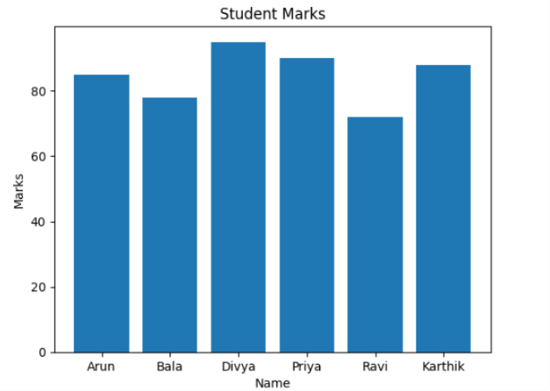

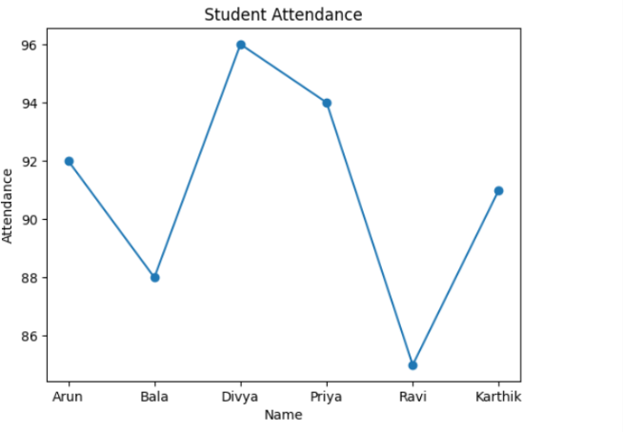
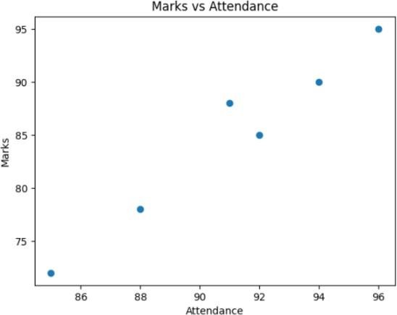

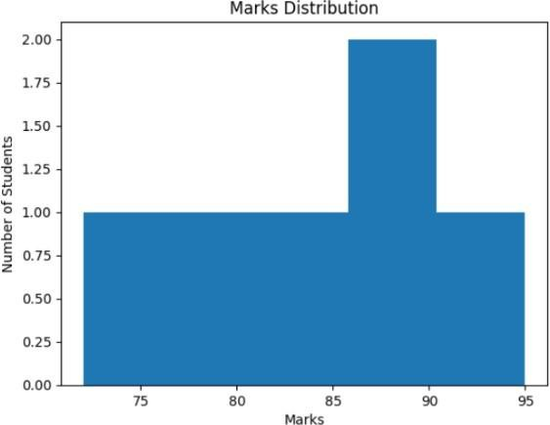

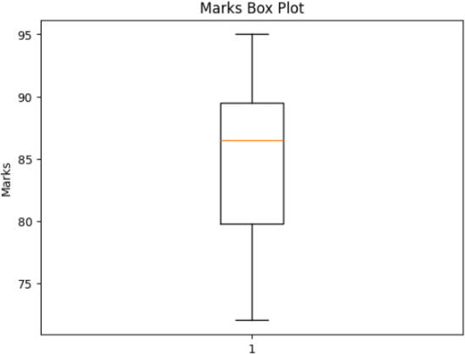

Result:

EXPT NO:4B | EXPLORATORY DATA ANALYSIS-DATA INSPECTION, FILTERING, STATISTICAL ANALYSIS AND CORRELATION

AIM:
To visualize and analyze the Global YouTube Statistics dataset using Python and create different charts to understand YouTube channel performance, subscriber distribution, video views, and identify important patterns.

PROCEDURE:
- Start the program.
- Import Pandas, Matplotlib, and Seaborn libraries.
- Load the Global YouTube Statistics CSV dataset.
- Display the first few records using head().
- Identify the numerical columns using select_dtypes().
- Create a bar chart to compare the top YouTube channels based on subscriber count.
- Create a box plot to examine the distribution and outliers in subscriber counts.
- Create a line chart to analyze video views of the first 20 YouTube channels.
- Add suitable titles, axis labels, legends, and grid lines.
- Display all the visualizations.
- Analyze the graphs and identify important patterns.
- Stop the program.

CODE:
import pandas as pd
import matplotlib.pyplot as plt import seaborn as sns

# Load Global YouTube Statistics dataset df = pd.read_csv(
"Global YouTube Statistics.csv", encoding="latin1"
)
# Display dataset print("Dataset Preview:") display(df.head())

# Select numerical columns num_cols = df.select_dtypes(
include="number"
).columns

print("\nNumerical columns:") print(num_cols.tolist())

#
# BAR CHART #
top10 = df.sort_values( "subscribers", ascending=False
).head(10) plt.figure(figsize=(10,5))
plt.bar(
top10["Youtuber"], top10["subscribers"] / 1000000
)

plt.title("Top 10 YouTubers by Subscribers") plt.xlabel("YouTube Channel") plt.ylabel("Subscribers (Millions)") plt.xticks(
rotation=45, ha="right"
)

plt.tight_layout() plt.show()

#
# BOX PLOT #
plt.figure(figsize=(8,5)) sns.boxplot(
x=df["subscribers"]
)

plt.title("Box Plot of YouTube Subscribers") plt.xlabel("Subscribers")

plt.tight_layout() plt.show()

#
# LINE CHART #
first20 = df.head(20) plt.figure(figsize=(10,5))
plt.plot(
range(1,21), first20["video views"], marker="o"
)

plt.title(
"Video Views of First 20 YouTube Channels"
)

plt.xlabel("Channel Record") plt.ylabel("Video Views")

plt.grid()

plt.tight_layout() plt.show()

OUTPUT:

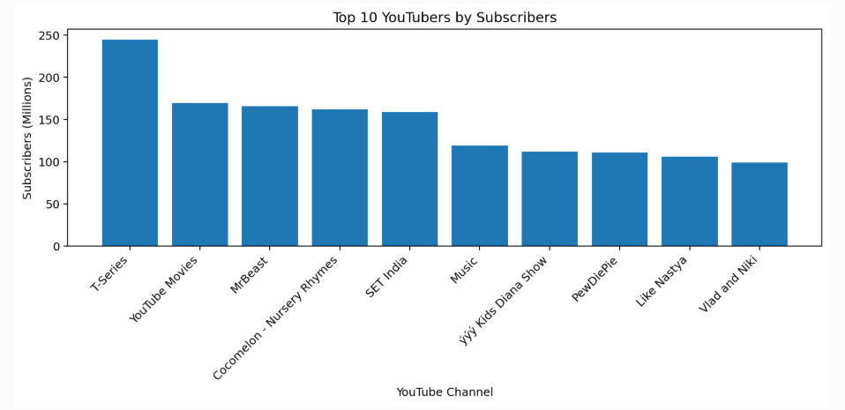

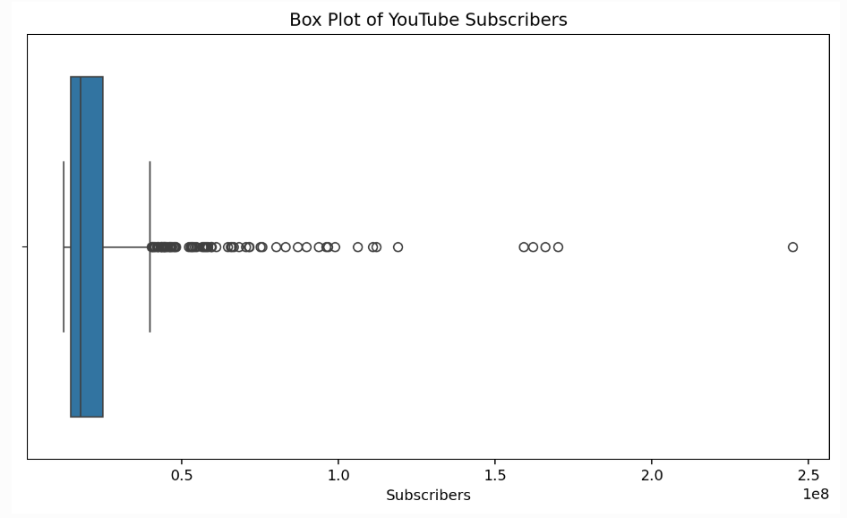

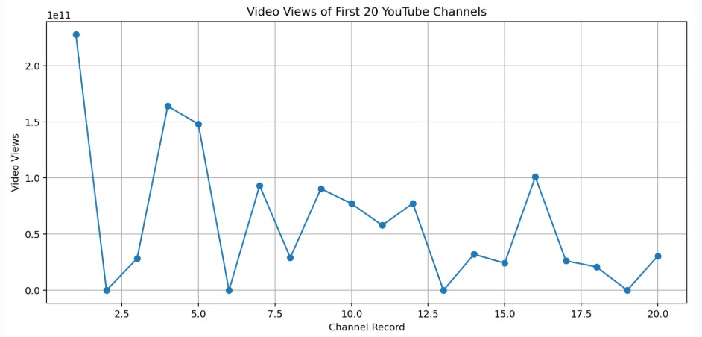

Result:

